**Introduction to Complex number**

**LAB # 05**



**Spring 2021**

**CSE301L-Signal $ System**

Submitted by: **Ashfaq Ahmad**

Registration No: **19PWCSE1795**

Class Section: **B**

“On my honor, as student of University of Engineering and Technology, I have neither given nor received unauthorized assistance on this academic work.”

Student Signature: ______________

Submitted to:

**Engr Durr-e-Nayab**

June 13, 2021

**Department of Computer Systems Engineering**

**University of Engineering and Technology, Peshawar**

**OBJECTIVES OF THE LAB**

‐‐‐‐‐‐‐‐‐‐‐‐‐‐‐‐‐‐‐‐‐‐‐‐‐‐‐‐‐‐‐‐‐‐‐‐‐‐‐‐‐‐‐‐‐‐‐‐‐‐‐‐‐‐‐‐‐‐‐‐‐‐‐‐‐‐‐‐‐‐‐‐‐‐‐‐

In this lab, we will cover the following topics:

* ***Gain familiarity with Complex Numbers and plot them***
* ***Complex exponential signals***
* ***Real exponential signals***

‐‐‐‐‐‐‐‐‐‐‐‐‐‐‐‐‐‐‐‐‐‐‐‐‐‐‐‐‐‐‐‐‐‐‐‐‐‐‐‐‐‐‐‐‐‐‐‐‐‐‐‐‐‐‐‐‐‐‐‐‐‐‐‐‐‐‐‐‐‐‐‐‐‐‐‐

**-------------------------TASK 01--------------------------**

* Write matlab function **zprint,** which takes a complex number and returns it real part, imaginary part, magnitude, phase in radians, and phase in degrees.

**Source code:**

function zprint % we can also write input and output arguments here.

disp('*********Task no 01********');

Z=input('please enter complex no:');

R=real(Z);

disp('Real part of complex no is: ');

disp('R=');

disp(R);

I=imag(Z);

disp('imagnary part of complex no is: ');

disp('I=');

disp(I);

M=abs(Z);

disp('Megnitude of complex no is: ');

disp('M=');

disp(M)

A=angle(Z);

disp('Angle of complex no in radian is: ');

disp('A=');

disp(A)

A2=A*180/pi;

disp('Angle of complex no in Degree is: ');

disp('A=');

disp(A2);

**OUTPUT:**

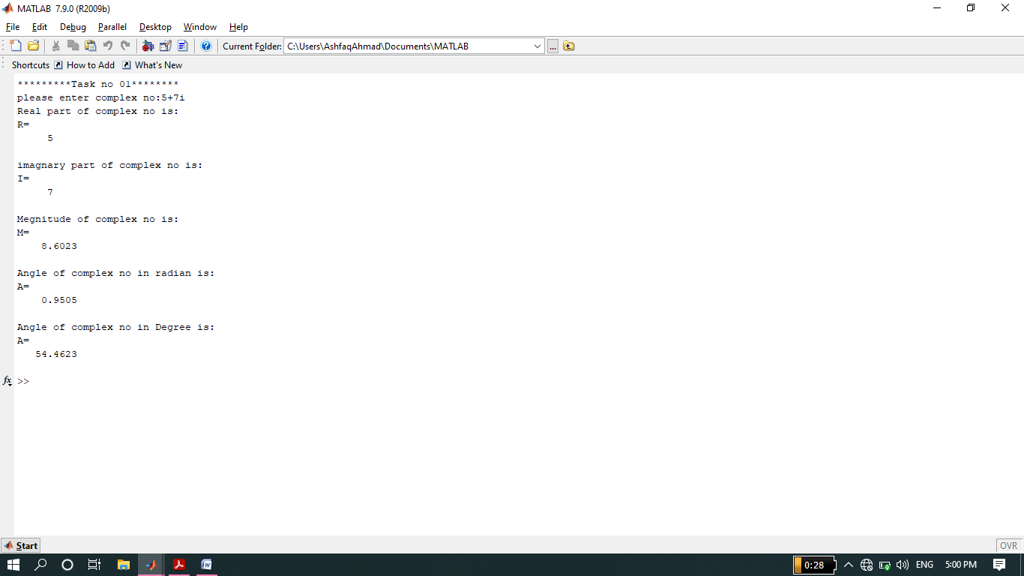

**---------------TASK 02--------------------------**

* Compute the conjugate ź (i.e. z_conj [give variable name]) and the inverse 1/z (i.e. z_inv [give variable name]) for any complex number z. Display the results numerically with zprint.

**Source code:**

function[z_conj z_inv]=print(Z)

disp('***********Task no 02*******')

z_conj=conj(Z);

z_inv=(1/Z);

**note: we can also write z_inv=inv(z).**

**Output:**

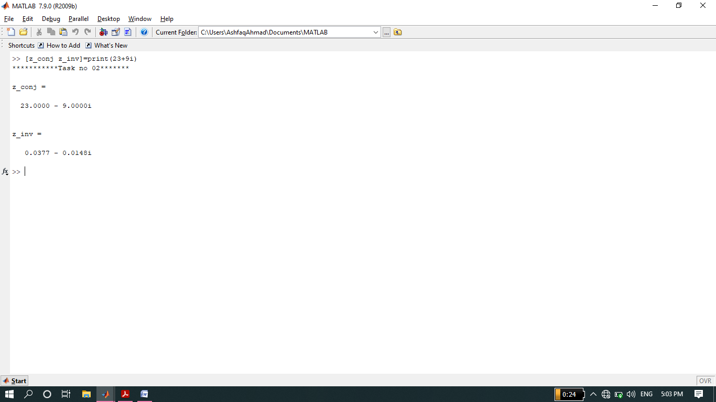

**-------------------------TASK 03--------------------------**

* Take two complex number and compute z1 +z2 and display the results numerically using zprint.

**Source code:**

function[z3]=sum

disp('*******task no 03******');

z1=input('please enter complex no 1: ');

z2=input('please enter complex no 2: ');

z3=z1+z2;

disp('Sum of z1 and z2 is: ');

**Output:**

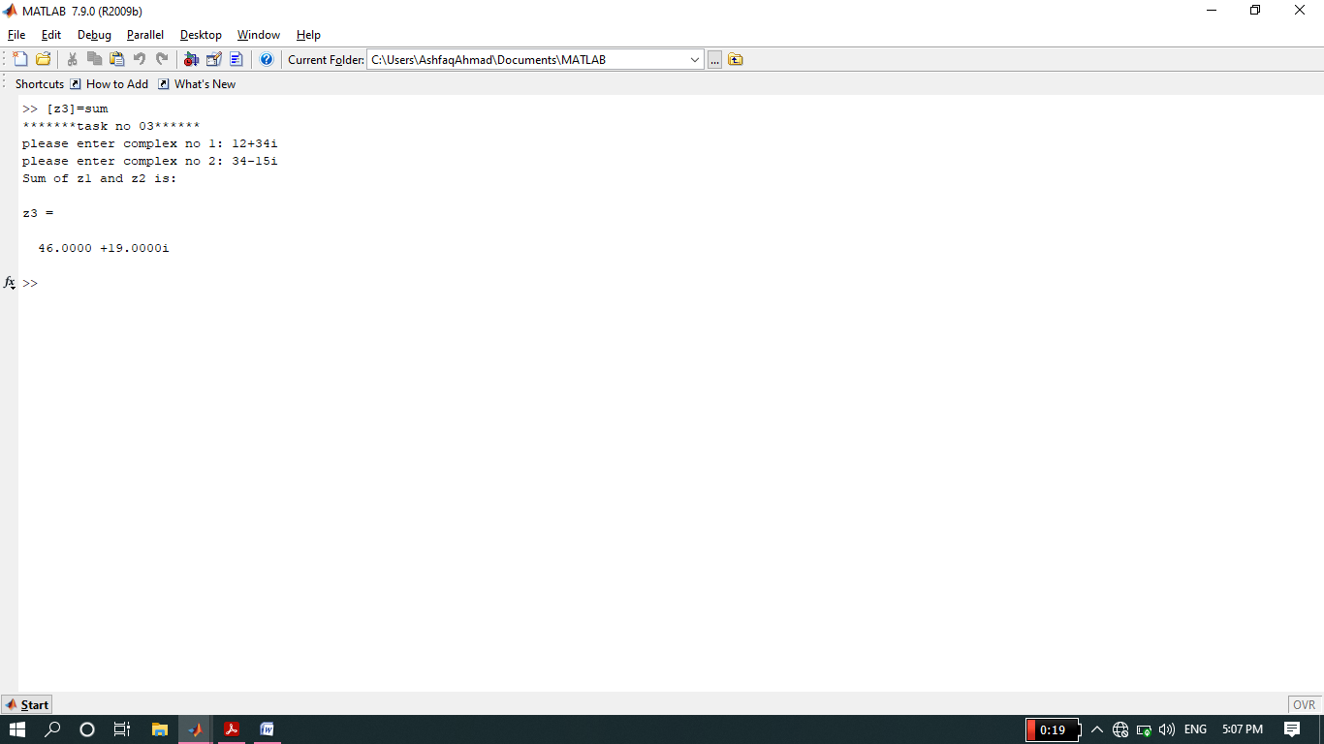

**-------------------------TASK 04--------------------------**

* Take two complex numbers and compute z1z2 and z1/z2. Use zprint to display the results numerically.

**Source Code:**

clc

clear all

close all

disp('*********Task no 04******');

Z1=input('please enter Z1: ');

Z2=input('please enter Z2: ');

Z3=Z1*Z2;

Z4=Z1/Z2;

disp('product of Z1 and Z2 is: ');

disp('product=');

disp(Z3);

disp('Division of Z1 and Z2 is: ');

disp('Division=');

disp(Z4);

**Output:**

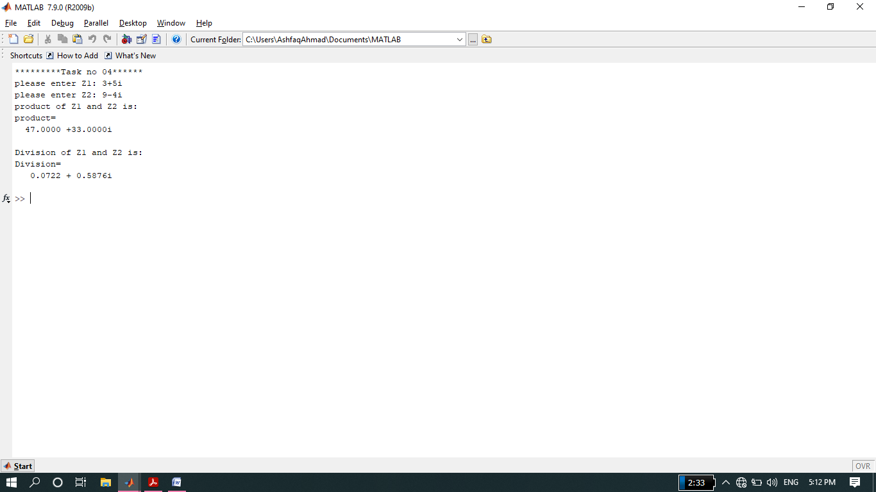

**-------------------------TASK 05--------------------------**

* Determine the complex conjugate of the exponential signal given in above example and plot its real and imaginary portions.

**Source code:**

function complex

%we can display all complex and congugate-complex numbes by passing output

%arguments x and y.

disp('*********task no 05********');

n=0:1/10:10;

k=5;

a=pi/2;

x=k*exp(n*a*i);

y=conj(x);

subplot(4,1,1)

stem(n,real(x),'r','linewidth',2);

xlabel('x-axis of real part');

ylabel('y-axis of real part');

title('Real part of Complex number');

grid on;

subplot(4,1,2)

stem(n,imag(x),'g','linewidth',2);

%('b','linewidth',2)=filled (same thing)

xlabel('x-axis of imagnary part');

ylabel('y-axis of imagnary part');

title('imagnary part of Complex number');

grid on;

subplot(4,1,3)

stem(n,real(y),'r','linewidth',2);

xlabel('x-axis of real part');

ylabel('y-axis of real part');

title('real part of Conjugate-Complex number');

grid on;

subplot(4,1,4)

stem(n,imag(y),'g','linewidth',2);

%('b','linewidth',2)=filled (same thing)

xlabel('x-axis of imagnary part');

ylabel('y-axis of imagnary part');

title('imagnary part of congugate-Complex number');

grid on;

**Output:**

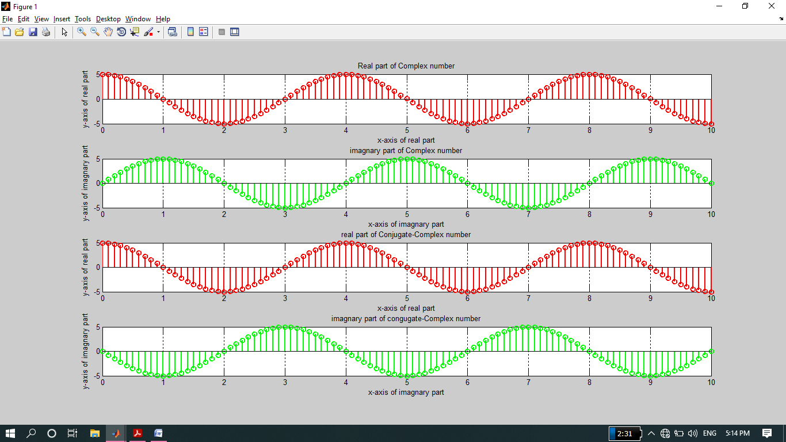

**-------------------------TASK 06--------------------------**

* Generate the complex valued signal and plot its magnitude, phase, the real part, and the imaginary part in separate subplots.

y(n) = exp (-0.2 + j0.5n), ‐10≤n≤10

**Source code:**

clc

clear all

close all

disp('*******task no 6******');

n=-10:1/10:10;

Z=exp(-0.2+0.5*n*j);

subplot(4,1,1)

stem(n,real(Z),'r','linewidth',1.5);

xlabel('x-axis');

ylabel('y-axis');

title('Real part of Z');

grid on;

subplot(4,1,2)

stem(n,imag(Z),'g','linewidth',1.5);

xlabel('x-axis');

ylabel('y-axis');

title('imagnary part of Z');

grid on;

subplot(4,1,3)

stem(n,abs(Z),'v','linewidth',1.5);

xlabel('x-axis');

ylabel('y-axis');

title('Megnitude of Z');

grid on;

subplot(4,1,4)

%we have to convert angle from radian to degree.

A=angle(Z);

A=(A*180/pi);

stem(n,A,'m','linewidth',1.5);

xlabel('x-axis');

ylabel('y-axis');

title('angle of Z');

grid on

**Output:**

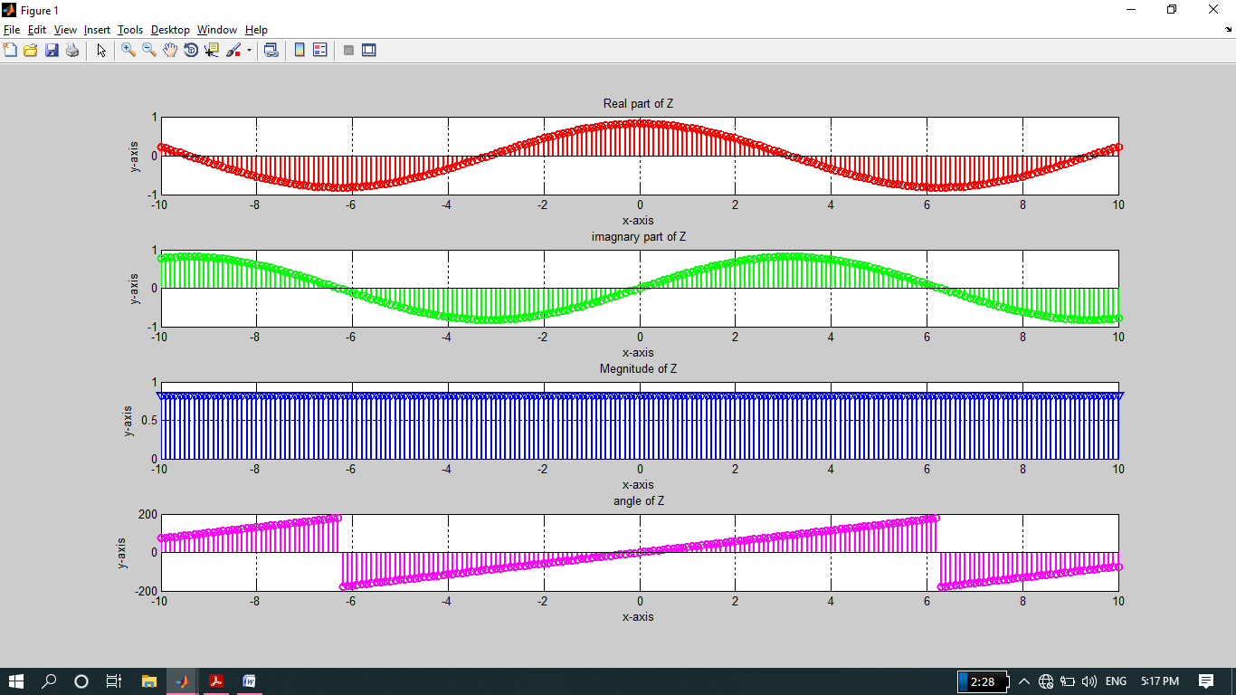

**-------------------------TASK 07--------------------------**

a) Generate a real‐exponential x=a * exp(n) for a=0.7 and n ranging from 0‐10. Find the discrete time as well as the continuous time version of this signal. Plot the two signals on same graph (holding both the graphs).

b) Repeat the same program with value of a=1.3.

**Source code:**

function Exponential

disp('**********Task no 07*********');

n=0:1/10:10;

a=0.7;

Z=a*exp(n);

figure (1)

plot(n,real(Z),'r','linewidth',2);

xlabel('x-axis');

ylabel('y-axis');

title('Real part of Z for a=0.7');

hold on

grid on;

stem(n,real(Z),'g','linewidth',2);

xlabel('x-axis');

ylabel('y-axis');

hold on;

grid on;

%Same program repeat for a=1.3

figure(2)

a=1.3;

Z=a*exp(n);

plot(n,real(Z),'r','linewidth',2);

xlabel('x-axis');

ylabel('y-axis');

title('Real part of Z for a=1.3');

hold on

grid on;

stem(n,real(Z),'g','linewidth',2);

xlabel('x-axis');

ylabel('y-axis');

hold on;

grid on;

**Output:**

* **Part (a) Output:**

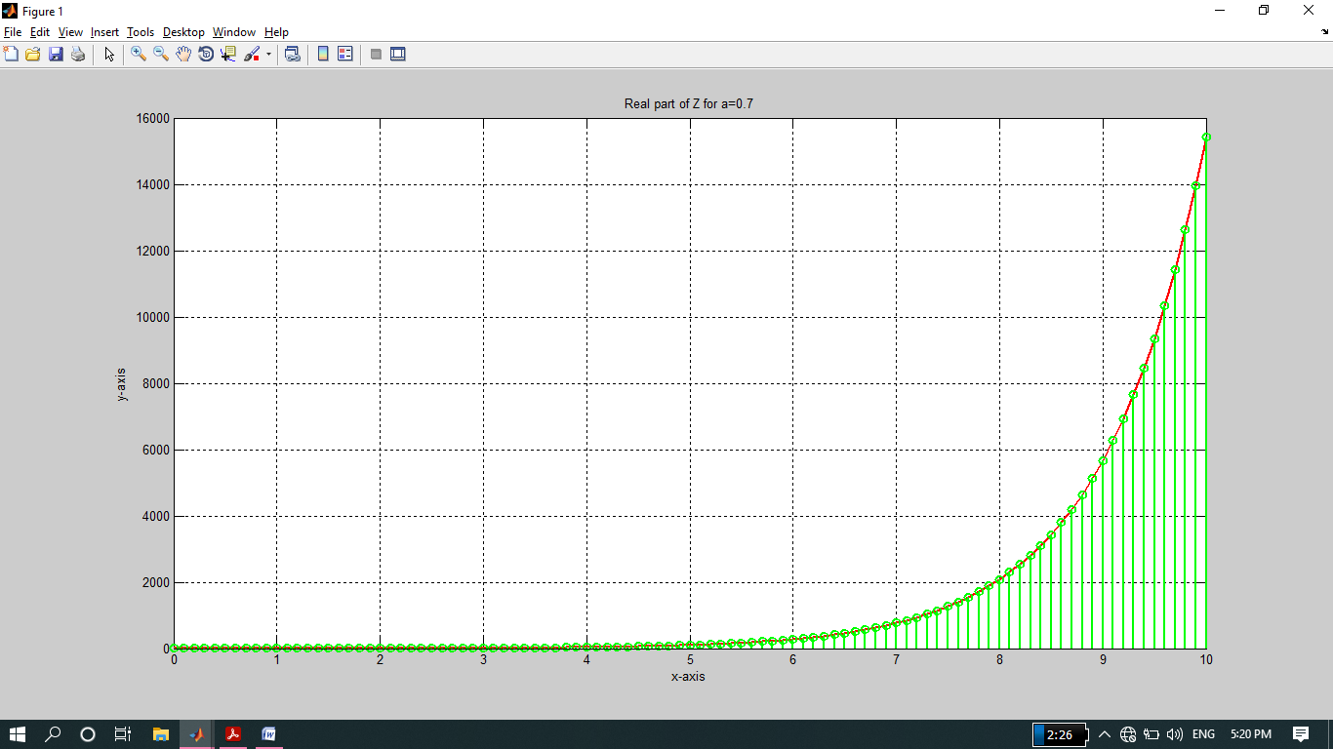

* **Part (b) Output.**

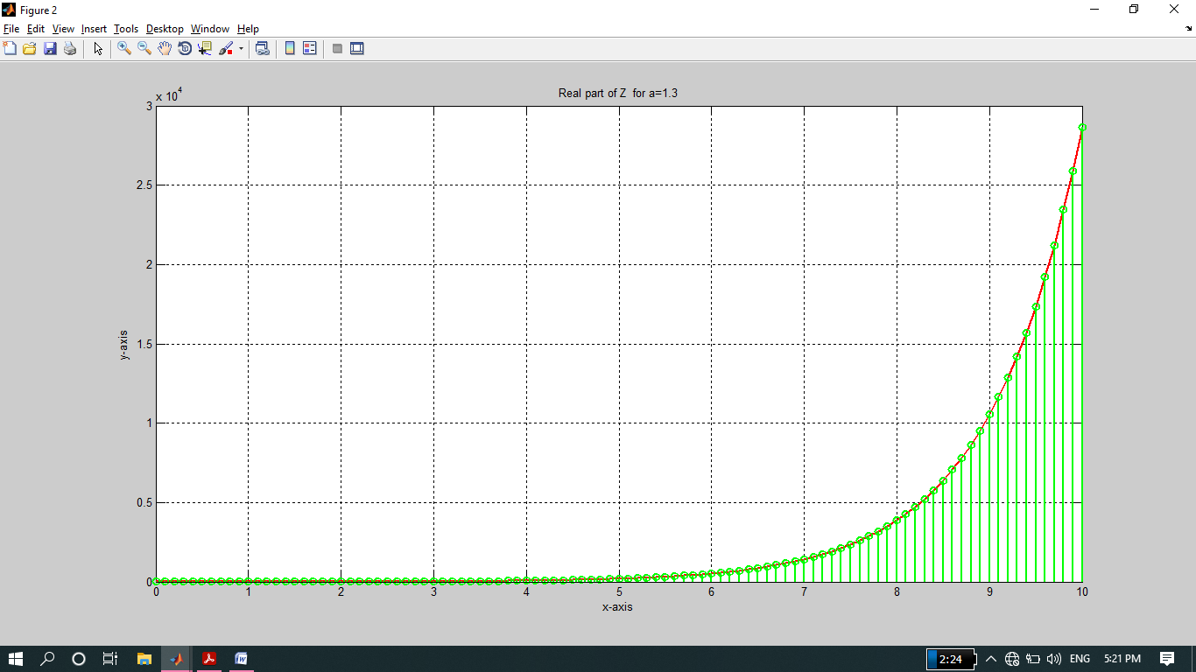

**-------------------------TASK 08--------------------------**

* Multiply the two discrete signals x1=5 exp (i*n*pi/4) and x2= a * exp(n) (use point‐by‐point multiplication of the two signals). Plot the real as well as the imaginary parts for 0<a<1 and a>1.

**Source code:**

clc

clear all

close all

disp('********task no 08**********');

n=1:1/10:10;

for a=0:1/10:1;

%for 0<=a<=1

x1=5*exp(i*n*(pi/4));

x2=a*exp(n); %this is not complex number

x3=x1.*x2;

end

figure(1);

subplot(2, 1, 1);

stem(n,real(x3),'g','linewidth',2);

xlabel('x-axis')'

ylabel('y-axis');

title('Real part');

subplot(2, 1, 2);

stem(n,imag(x3),'m','linewidth',2);

xlabel('x-axis')'

ylabel('y-axis');

title('Imaginary Part');

for a=2:1/10:10;

%for a>1

x1=5*exp(i*n*(pi/4));

x2=a*exp(n);

x3=x1.*x2;

end

figure(2);

subplot(2, 1, 1);

stem(n,real(x3),'g','linewidth',2);

xlabel('x-axis')'

ylabel('y-axis');

title('Real part');

subplot(2, 1, 2);

stem(n,imag(x3),'m','linewidth',2);

xlabel('x-axis')'

ylabel('y-axis');

title('Imaginary Part');

**Output:**

* **For 0<=1<=1:**

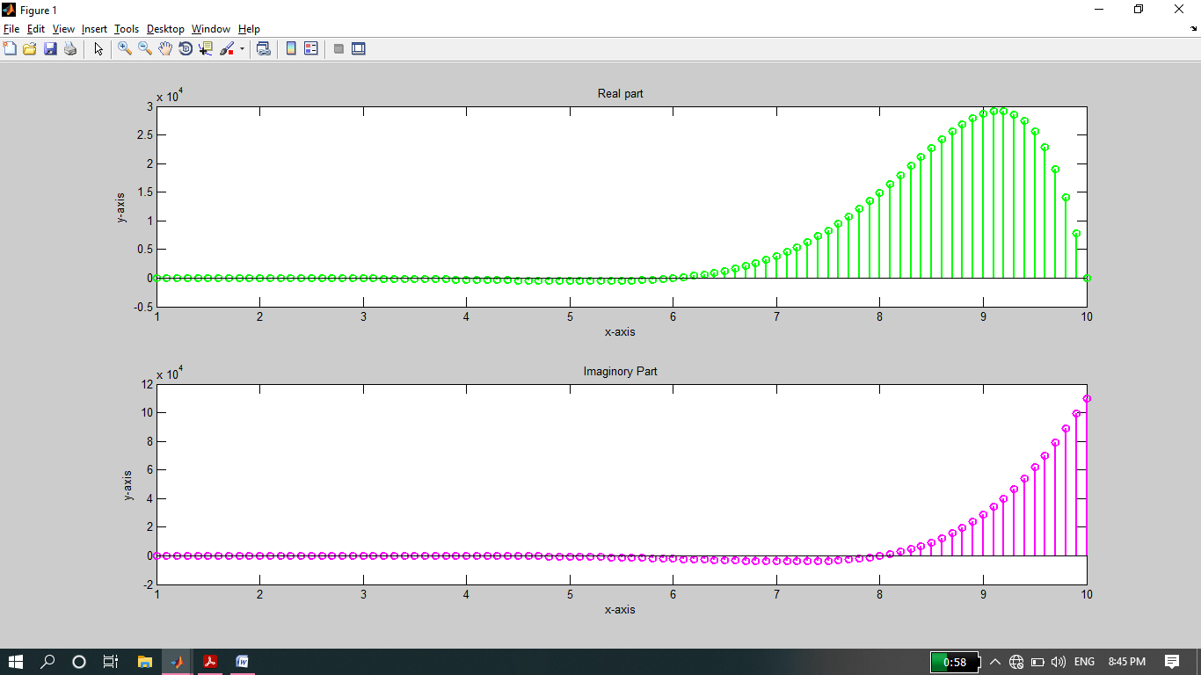

* **For a>1:**

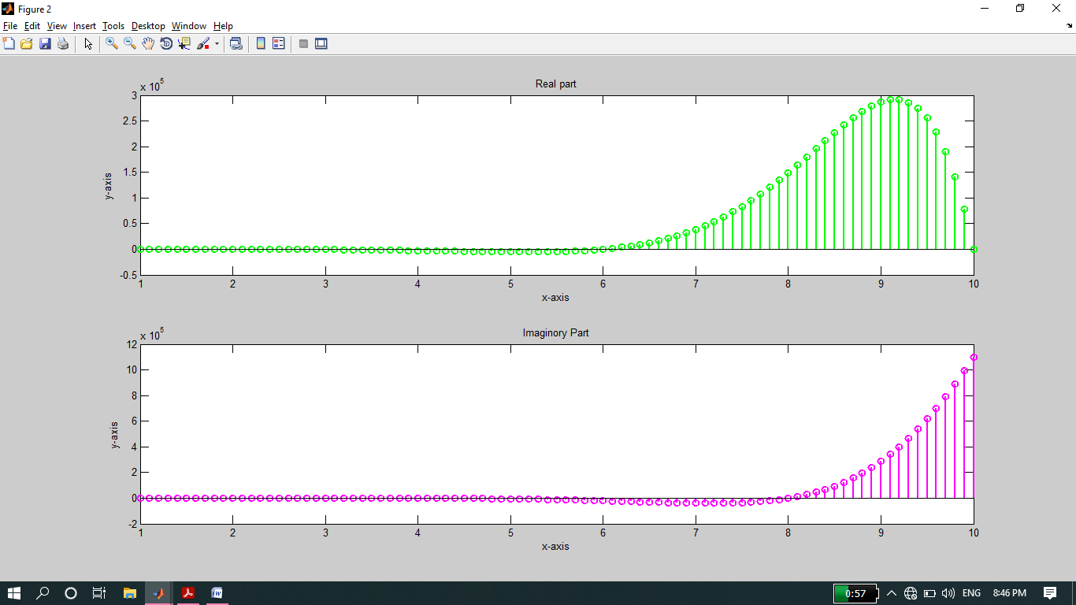

**-------------------------TASK 09--------------------------**

* Plot the discrete signal x=a^|n| for n ranging from ‐10 to 10. Draw two subplots for 0<a<1 and a>1.

**Source code:**

function task09

disp('**********Task no 09*******');

n=-10:1:10;

for a = 0:0.1:1

x1 = a.^ abs(n);

end

for a =1:0.1:4

x2 = a.^abs(n);

end

subplot(2, 1, 1);

stem(n,x1,'g','linewidth',2);

xlabel('x-axis')'

ylabel('y-axis');

title('Descrete signal for x-range(0<=x<=1)');

grid on

subplot(2, 1, 2);

stem(n,x2,'m','linewidth',2);

xlabel('x-axis')'

ylabel('y-axis');

title('Descrete signal for x-range (a>1)');

grid on

**Output:**

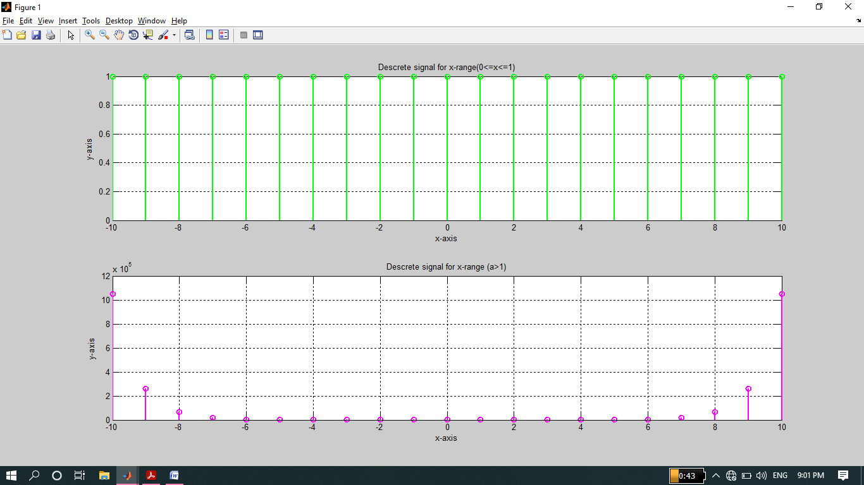

**-------------------------TASK 10--------------------------**

1. Generate the signal x(t) = Ae(jωt + π) for A = 3, π= ‐0.4, and ω = 2π(1250). Take a range for t that will cover 2 or 3 periods.
2. Plot the real part versus t and the imaginary part versus t. Use subplot(2,1,i) to put both plots in the same window.
3. Verify that the real and imaginary parts are sinusoids and that they have the correct frequency, phase, and amplitude.

**Part (a)**

**Source code:**

clc

clear all

close all

disp('*********task no 10*********');

a=3;

pai=-0.4;

w=2*pai*1250;

t=1:1/10:4; %it will cover 2 to 3 period.

x=a*exp(pai+(w*t*j));

subplot(2,1,1)

plot(t,real(x),'r','linewidth',2);

xlabel('time-t');

ylabel('real-part of Z');

title('Complex Number');

grid on;

subplot(2,1,2)

plot(t,imag(x),'g','linewidth',2);

xlabel('time-t');

ylabel('imagnary-part of Z');

title('Complex Number');

grid on;

**Part (b)**

**Output:**

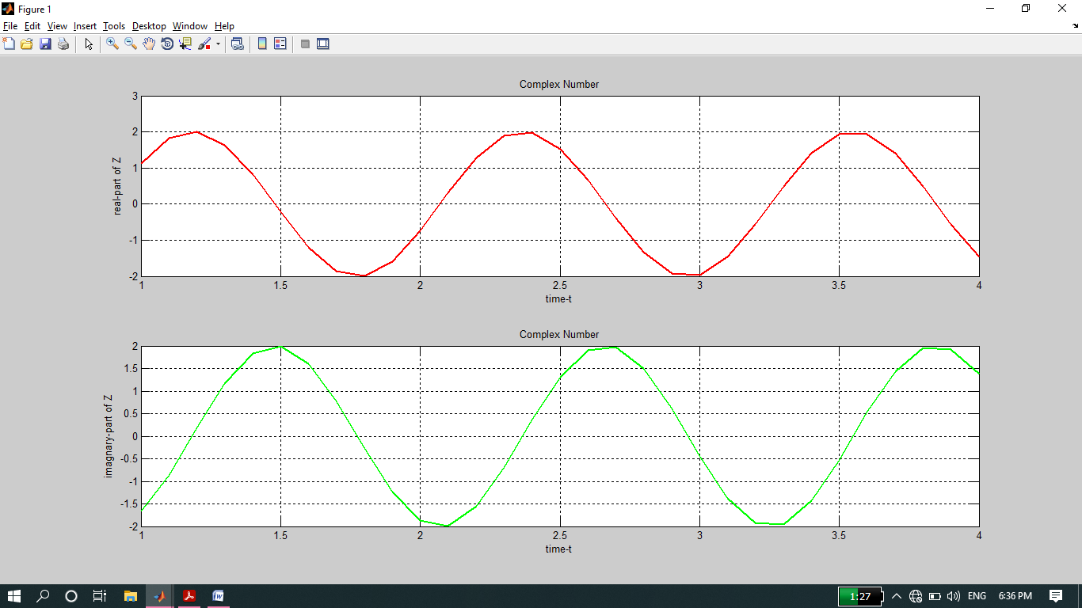

**Part (c):**

* Thus, it is verified that both imaginary and real part are sinusoid and have the correct frequency, phase, and amplitude.

**THE END**